**Final Project**

**Background**

Upregulation of growth factor receptors plays a role in many types of cancers. Many anti-cancer therapies act by inhibiting these receptors.

***Example: Epidermal Growth Factor Receptors***

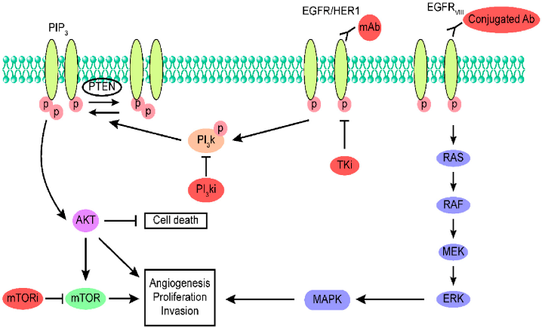

**Background Reading (pdf on ELC):**

***Lacal PM and Graziani G. “Therapeutic implication of vascular endothelial growth factor receptor-1  
(VEGFR-1) targeting in cancer cells and tumor microenvironment by competitive and non-competitive inhibitors”. Pharmacological Research 136 (2018): 97-107.***

Abstract

The vascular endothelial growth factor receptor-1 (VEGFR-1) is a tyrosine kinase receptor for VEGF-A, VEGF-B, and placental growth factor (PlGF) ligands that is expressed in endothelial, myelomonocytic and tumor cells. VEGF-B and PlGF exclusively bind to VEGFR-1, whereas VEGF-A also binds to VEGFR-2. At variance with VEGFR-2, VEGFR-1 does not play a relevant role in physiological angiogenesis in the adult, while it is important in tumor-associated angiogenesis. VEGFR-1 and PlGF are expressed in a variety of tumors, promote invasiveness and contribute to resistance to anti-VEGF-A therapy. The currently approved antiangiogenic therapies for the treatment of a variety of solid tumors hamper VEGF-A signaling mediated by both VEGFR-2 and VEGFR-1 [i.e., the monoclonal antibody (mAb) anti-VEGF-A bevacizumab, the chimeric molecule aflibercept and several small molecule tyrosine kinase inhibitors] or exclusively by VEGFR-2 (i.e., the mAb anti-VEGFR-2 ramucirumab). However, molecules that interfere with VEGF-A/VEGFR-2 signaling determine severe adverse effects due to inhibition of physiological angiogenesis and their efficacy is hampered by tumor infiltration of protumoral  
myeloid cells. Blockade of VEGFR-1 may exert anti-tumor activity by multiple mechanisms: a) inhibition of tumor-associated angiogenesis; b) reduction of myeloid progenitor mobilization and tumor infiltration by VEGFR-1 expressing M2 macrophages, which contribute to tumor progression and spreading; c) inhibition of invasiveness, vasculogenic mimicry and survival of VEGFR-1 positive tumor cells. As a consequence of these properties, molecules targeting VEGFR-1 are expected to produce less adverse effects and to counteract resistance towards anti-VEGF-A therapies. More interestingly, selective VEGFR-1 inhibition might enhance the efficacy of immunotherapy with immune checkpoint inhibitors. In this review, we will examine the experimental evidence available so far that supports targeting VEGFR-1 signal transduction pathway for cancer treatment by competitive inhibitors that prevent growth factor interaction with the receptor and non-competitive inhibitors that hamper receptor activation without affecting ligand binding

**Problem Statement (all entities are fictional)**

When the growth factor Problatide binds to its receptor GF-R, it triggers cell division. Problatide is formed from its precursor Suproblatide through the action of the enzyme Extrase.

However, when GF-R is overexpressed, it can lead to excess cell division and tumor formation. Multiple therapies are being investigated to block the excessive cell division caused by GF-R. It is unclear whether it is best to target inhibition of the GF-R receptor, or whether it is better to block the system upstream by inhibiting the enzyme Extrase.

The small molecule Fixaprob has been found to bind to and inhibit the GF-R receptor with high affinity. However, it also binds to a receptor in the liver and can cause liver toxicity. It has lower affinity for this receptor, but still has significant potential for severe liver damage at high concentrations.

The enzyme inhibitor Blocextra is a potent inhibitor of Extrase and may offer a better alternative. However, the growth factor Problatide has other important and necessary physiological effects besides its action through the GF-R receptor. For example, it binds to other receptors and helps maintain blood vessel integrity and plays a role in wound healing. Excessive reduction of the production of Problatide may cause serious adverse effects such as aneurysms, internal bleeding, infected wounds, etc.

Complicating matters further, there is a feedback between GF-R and Extrase, such that when the fraction of GF-R bound by Problatide increases, it suppresses the production of Extrase, and vise versa.

***In this project, you will determine whether there are viable doses of either Fixaprob, Blocextra, or a combination of two, that is likely to suppress tumor growth without causing severe adverse events.***

Let’s start simple. For now, ignore the feedback between GF-R and Extrase. You may also assume that internalization of the Problatide-GF-R complex is negligible.

Let’s define:

E 🡪 Extrase

S 🡪 Superproblatide

P 🡪 Problatide

R 🡪 GF-R

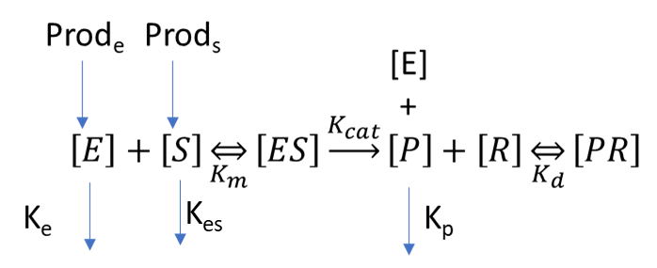

The following parameters have been measured experimentally or clinically:

|  |  |  |
| --- | --- | --- |
| Symbol | **Definition** | **Value** |
| Km | Michaelis Menten constant for Extrase and Suproblatide | 1.25 nM |
| Kcat | Catalysis rate constant for extrase conversion of Suproblatide of Problatide | 4 /sec |
| Ke | Extrase elimination rate constant | 1 /sec |
| Kes | Suproblatide elimination rate constant | 0.1 /sec |
| [P]SS | Steady state Problatide concentration | 20 pmol/L |
| [S]SS | Steady state Suproblatide concentration | 10 pmol/L |
| [E]tot,SS | Steady state total Extrase concentration | 0.5 pmol/L |
| Kd | Binding affinity of Problatide for the GF-R receptor | 10 pmol/L |

For Case 1, you can assume that Problatide is being produced at a constant rate (i.e. you do not need to worry about the upstream enzymatic process). Therefore you do NOT need to use the ODE model. You only need to consider the principles of ligand-receptor binding and competitive antagonists. These calculations may even be done by hand if you prefer (although you still need to use R for part E).

1. At steady state under the conditions in the table above, what is the normal fraction of GF-R that is bound with problatide?

Fb = [P] / ([P] + Kd)

Fb = 20 / 30 = 0.667

1. If the receptor concentration is normally 0.1 pM, what is the concentration of the receptor-ligand complex normally?

Fb = 0.667

So,

0.667 * 0.1pM = 0.0667pM

1. In cancerous tissue, GF-R is upregulated so that its expression is 3 times greater than normal. What is the concentration of the receptor-ligand complex in cancerous tissue?

Unregulated receptor concentration = 0.1pM * 3 = 0.3pM

Fb = 0.667

So,

0.667 * 0.3pM = 0.2001pM

1. One goal of therapeutic intervention may be to return the receptor-ligand complex concentration to pre-cancer levels (since this is what exerts physiological effects). What should the target fraction-bound be to achieve this?

For cancerous: 0.2001pM

Non-cancerous: 0.0667pM

So,

Fb_target = 0.667 / 3 = 0.222

1. Assume the receptor inhibitor Fixaprob binds to GF-R with a binding affinity 10 pM. Generate a plot of fraction bound (y-axis) as a function of Fixaprob concentration (x-axis).

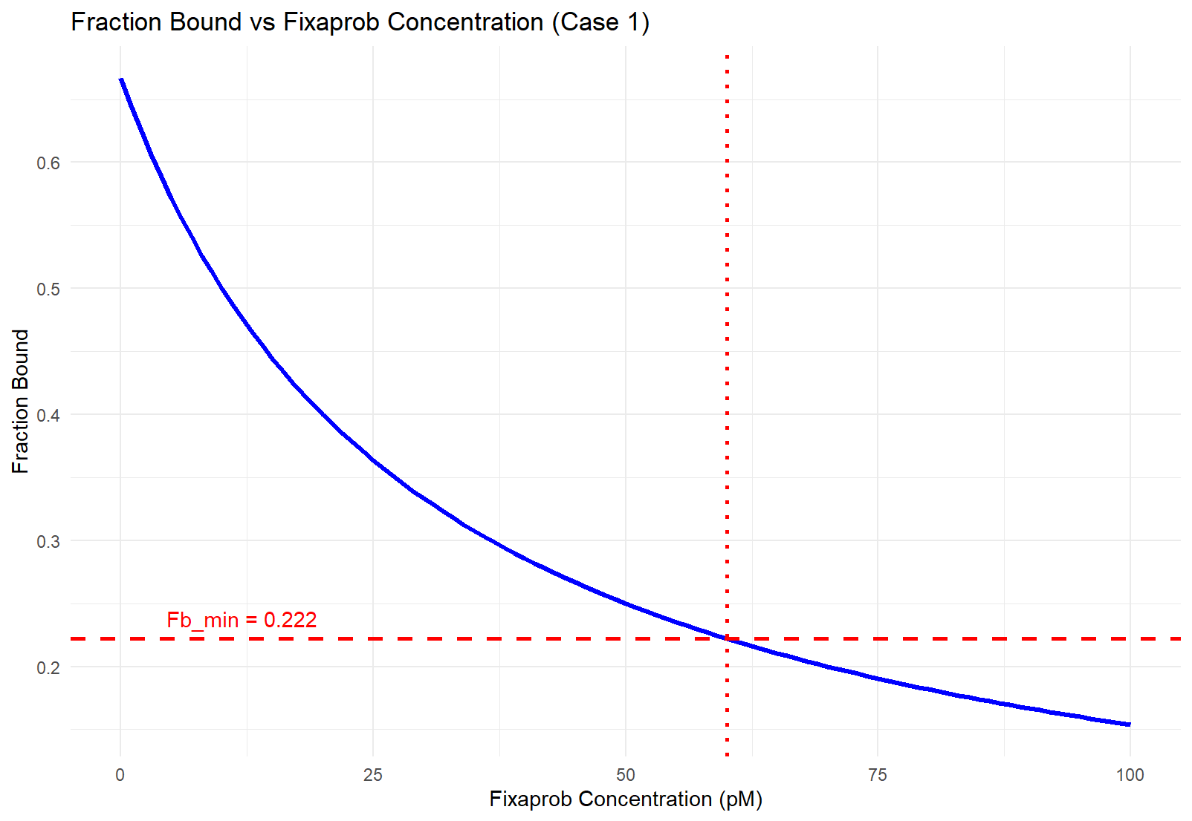

1. What is the minimum concentration of Fixabrob required to achieve the necessary level of reduction in fraction bound?

The minimum concentration of Fixabrob was found to be 60pM.

I found this by running an interpolation of the data shown above. The intersection of the red lines indicate the minimum concentration required to reach the minimum fraction bound.

1. It has been determined that Fixaprob’s liver toxicity begins to occur at concentrations above 75 pM. Is it possible to treat this cancer with this drug while also avoiding liver toxicity?

It was determined that the minimal concentration required in reduction of fraction bound is 60pM. Therefore, it **IS** possible to treat this cancer with this drug while avoiding toxicity.

(We can use concentrations from 60pM 🡪 75pM).

**Case 2.**

Now assume that there is a feedback between PR and enzyme concentration. The following data was collected in experiments in rats treated with Fixaprob.

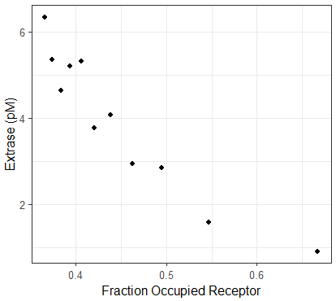

From this point on, you can no longer assume that problatide is being produced at a constant rate, since the upstream concentrations of enzymes and or substrates may be changing. Therefore you will need to use the ODE model.

1. Assuming that the feedback mechanism is conserved between rats and humans, what is a reasonable functional for the feedback mechanism. To limit the number of feedback structure possibilities, you may assume that it follows a power-law relationship:

Feedback = ${\left(\frac{{PR}_{ss}}{PR}\right)}^{n}$

What is n?

Hint: One way to do this is to vary the drug concentration and simulate both the fraction receptor occupied and extrase concentration, using different assumptions for n, and find the value that most closely reproduces this data.

You could also use optimization to determine its value, but that is not necessary for this lab.

1. Assume again that the receptor inhibitor Fixaprob binds to GF-R with a binding affinity of 10 pM. Simulate for 3 days using the Fixaprob concentration you determined in Case 1, part F, and generate a figure with 4 subplots: Et, St, P, and fraction bound.

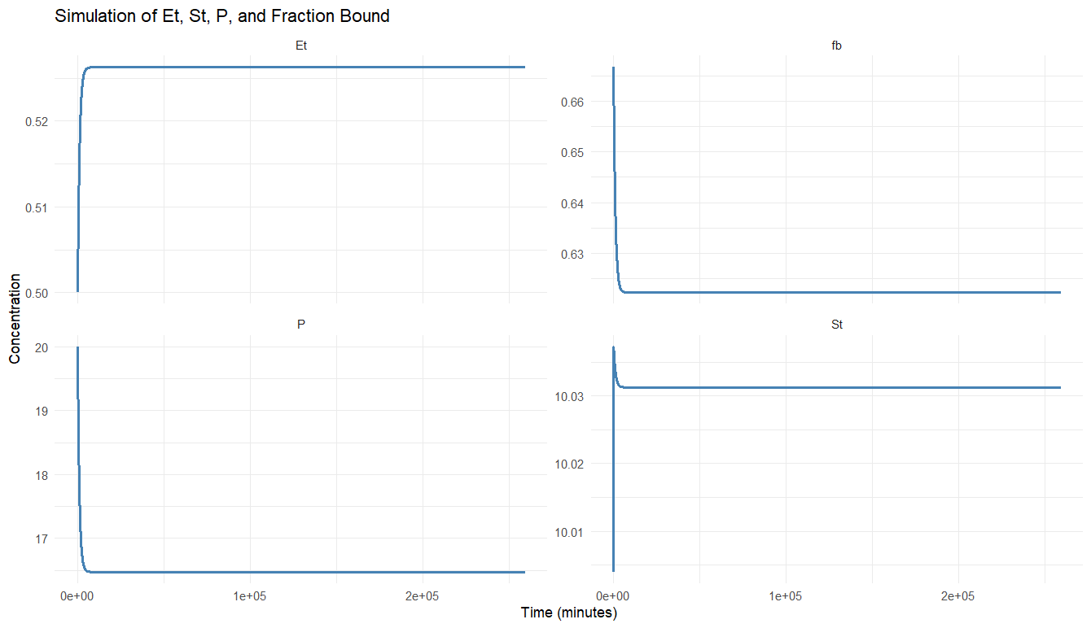

1. As you did in Case 1, Part E, generate a plot of fraction bound (y-axis) as a function of Fixaprob concentration (x-axis).

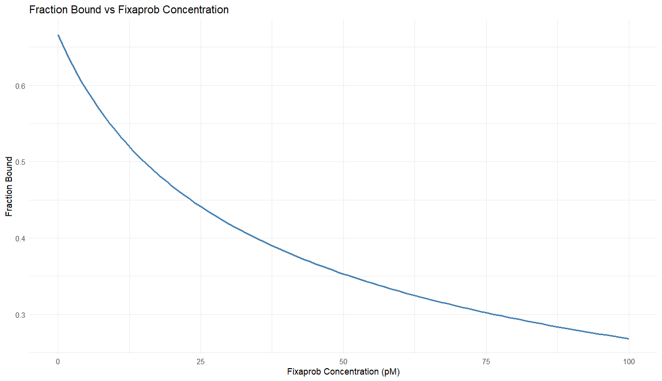

1. When this feedback is present, what concentration of drug is required to reach the necessary degree of inhibition? If it is different from Case 1, explain in 1-3 sentences what you think is happening.

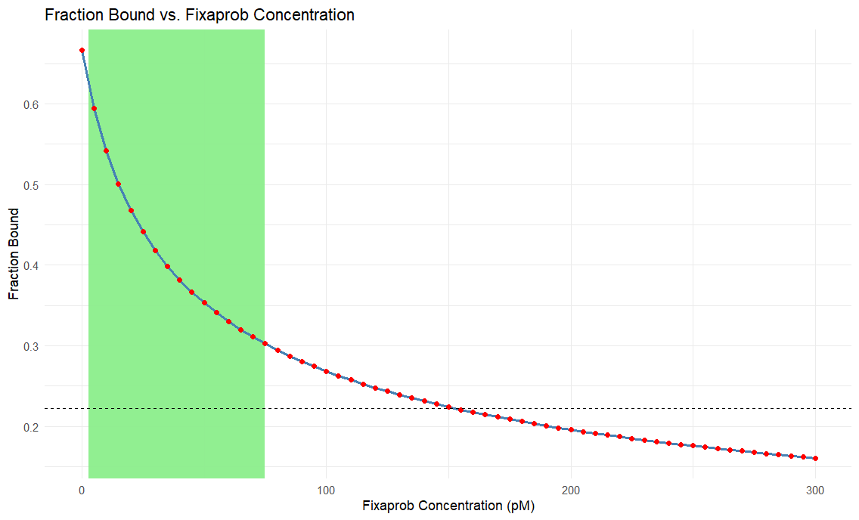

The required concentration is much higher than in case 1. In the plot above, I shaded in green the range of concentrations (0.222 🡪 75)pM. A fraction bound of 0.222 occurs at ~150pM.

Unlike the equilibrium approach in Case 1, where the system is static, the enzyme and substrate are interacting and changing over time. This requires a higher concentration of Fixaprob to achieve the same level of inhibition.

1. Is it possible to treat this cancer with this drug while also avoiding liver toxicity?

No, it is not possible to treat this drug while avoiding liver toxicity. As seen in the plot above, the green zone indicates safe levels of treatment while avoiding liver toxicity.

**Case 3**

Now you will investigate whether the necessary reduction in bound fraction can be achieved with the enzyme inhibitor Blocextra, which has a binding affinity for Extrase of 1 pM.

Note: For this part, make sure to set the concentration of Fixaprob back to zero! Leave the feedback turned on.

1. Simulate a range of concentrations of Blocextra for 3 days, and generate a plot of fraction bound (y-axis) as a function of Blocextra concentration (x-axis).

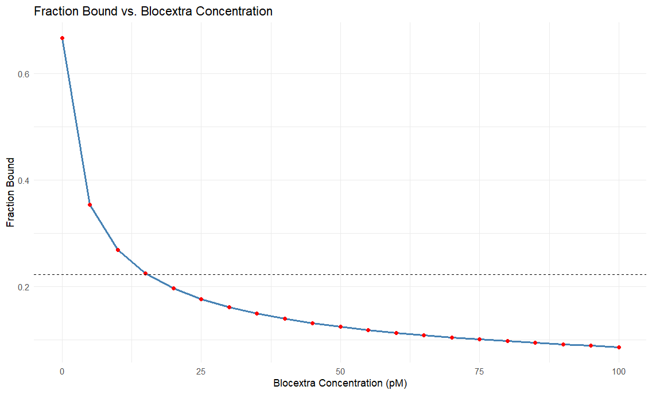

1. What is the minimum dose of Blocextra necessary to achieve the required reduction in probletide-GF-R bound fraction?

After running a simulation for three days, it was found that the minimum concentration of blocextra required is 15pM (See intersection of dashed line with data above)

1. For this concentration of Blocextra, generate a figure with 4 subplots: Et, St, P, and fraction bound.

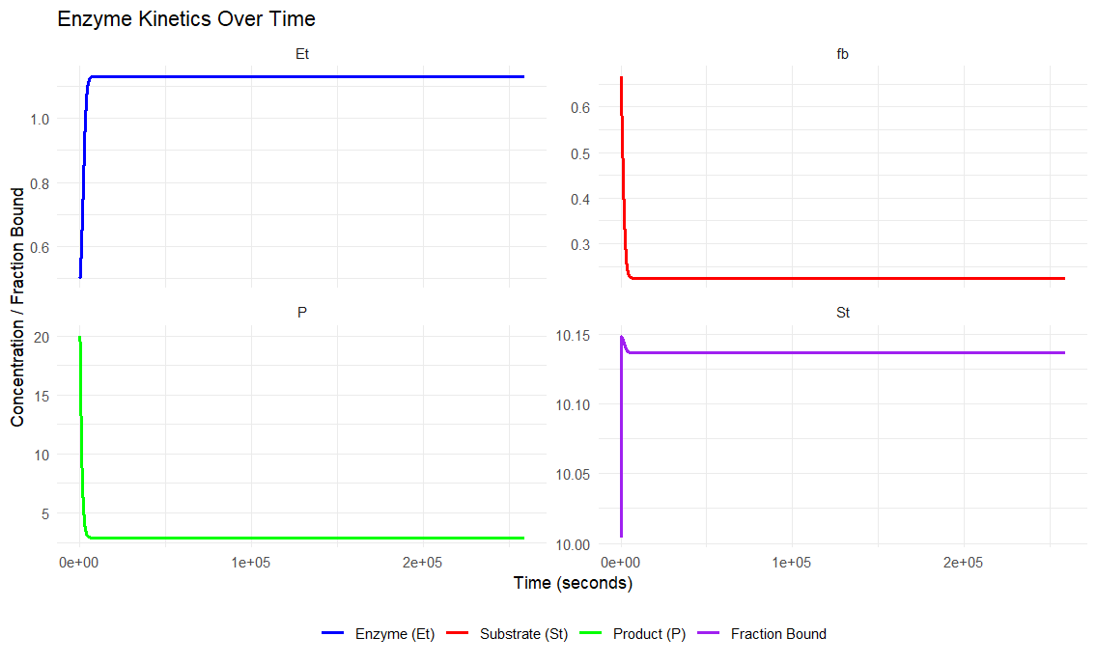

1. At this concentration of Blocextra, what is the resulting concentration of free Probletide?

After running the simulation, I printed the final concentration to the console:  
Et = 1.130772

1. Because Probletide also has other important physiological effects such as maintaining blood vessel integrity and helping with wound healing, serious adverse events can occur if it’s concentration drops too low. Animal experiments indicate that the Probletide concentration must be above 8 pM to prevent serious events. Given your answers above, is it possible to treat this cancer with this drug while also avoiding serious adverse events?

It seems unlikely. In order to reach the minimum safe free Probletide concentration (8pM), an initial concetration of 1953pM of Blocextra is required. I tested this by adjusting the concetration of Blocextra in the simulation until the minimum value was reached.

1. If you could design a drug with a higher or lower binding affinity for the enzyme, would this help fix the problem? Why or why not?

A higher binding affinity drug might help in this scenario because it limits the enzyme's ability to bind Probletide. This could allow more free-Probletide to stay available in the system. This would help in maintaining the minimum safe concentration of Probletide.

Case 4:

Given the limitations of each drug alone, you will now consider whether it is possible to use a combination of Blocextra and Fixaprob to more effectively and safetly suppress tumor growth.

1. Can you identify concentrations of each (or a range of concentrations of each) that can meet all of the following criteria:
2. Suppresses fraction bound below its normal level.
3. Keeps Fixaprob concentration below the limit for liver toxicity (see part 2).
4. Keeps Probletide concentrations above the level needed for normal blood vessel function and wound healing (see part 3).
5. Using your recommended concentrations, simulate for 3 days, and generate a figure with 4 subplots: Et, St, P, and fraction bound.
6. At the concentrations recommended in A, given in combination, what is the resulting Probletide-GF-R bound fraction?
7. At the concentrations recommended in A, given in combination, what is the resulting Probletide free concentration?

**Deliverables:**

You do NOT need to write a formal report.

In the document above, copy and paste your figures, and type your answers in blue font (so that your answers can be distinguished from the assignment text).

Then copy and paste your R code below.